**System Electronics Independent Risk Investigation**

**Energy Management System**

Project Description:

This project is to develop a modular power control and monitoring solution for homes and small business energy management.

Component Description:

The high risk component addressed in this report is the power monitoring and control hardware design for the load modules of the Energy Management System.

April 7, 2015

**Author: Donald MacIntyre – djm4912@rit.edu**

**Team Members: Andrew Cope – ajc4630@rit.edu**

**Jacob Lauzon – jfl4577@rit.edu**

**Ryan McLaughlin – rpm6651@rit.edu**

Table of Contents

1 Overview 5

1.1 AC To DC Power Conversion 7

1.2 Surge Protection 8

1.3 Switching Control 8

1.4 Power Sensing 8

1.5 Controller 9

2 Risk Specification 9

2.1 Marketing Requirements 9

2.2 AC TO DC Conversion 11

2.3 Surge Protection 11

2.4 Switching Control 11

2.5 Current Sensing 12

2.6 Voltage Sensing 12

3 Risk Investigation 12

3.1 AC to DC Conversion 12

3.1.1 Capacitive Coupled Circuit 12

3.1.2 Linear Supply 13

3.1.3 Switch Mode Supply (Flyback) 13

3.2 Surge Protection 13

3.2.1 Gas Discharge Tube (GDT) 13

3.2.2 Transient Voltage Suppression (TVS) 14

3.2.3 Metal Oxide Varistor (MOV) 14

3.2.4 Thyristor Surge Protection Device (TSPD) 14

3.3 Switching Control 14

3.3.1 Triac 14

3.3.2 Relay 15

3.3.3 Transistor 15

3.4 Power Sensing 15

3.4.1 Current Sensing 15

3.4.2 Voltage Sensing 16

3.5 Controller 17

3.5.1 Texas Instruments – MSP430 Low Power Family 17

3.5.2 Peripheral Interface Controller (PIC) – PIC16F873A 18

3.5.3 STMicro – STPMXX Family 18

3.6 Concept Selection 18

3.6.1 Power Supply 19

3.6.2 Surge Protection 20

3.6.3 Load Switching 21

3.6.4 Power Sensing 21

3.6.5 Controller 23

4 Risk Mitigation Design 23

4.1 Power Supply 23

4.1.1 Generation 1 - Power Supply Implementation 24

4.1.2 Generation 2 – Power Supply Implementation 25

4.1.3 Power Supply Design Risk Mitigation Summary 26

4.2 Load Switch 26

4.2.1 Load Switch Design Risk Mitigation Summary 28

4.3 Power Sensing 28

4.3.1 Current Sensing 29

4.3.2 Voltage sensing 30

4.4 Surge Protection 33

4.4.1 Surge Protection Design Risk Mitigation Summary 33

4.5 Controller 33

4.5.1 Controller Design Risk Mitigation Summary 35

4.5.2 Intellectual Property 35

5 Parts List 35

6 Testing Strategy 36

6.1 Phase 1 37

6.1.1 Power Supply 37

6.1.2 Surge Protection 37

6.1.3 Voltage Sense 37

6.1.4 Current Sense 37

6.2 Load Switch 38

6.3 Phase 2 38

6.4 Phase 3 38

6.5 Phase 4 39

6.6 Testing Schedule 39

7 Uncertainties 40

7.1 Power Supply 40

7.2 Surge Protection 40

7.3 Switching Control 40

7.4 Current Sensing 40

7.5 Voltage Sensing 40

7.6 Controller 40

8 Appendix 41

# Overview

In order to accomplish the desired functionality of the Energy Management System of monitoring and controlling the operation of electrical loads, electrical hardware is needed in order to accurately measure current, measure voltage, and perform load switching. The purpose of this document is to provide an understanding of the risks related to the system electronics for the Energy Management System, and provide the steps forward to mitigate these risks. The system electronics are very important as system functionality will be dependent on them working accurately and reliably.

The Energy Management System is a system designed to allow for monitoring and management of power usage with the objective of providing energy conservation for a home or small business. The system provides an easy method of monitoring, managing and controlling power consumption of all connected electrical loads. The system consists of two main components, the main hub and separate outlet modules. The main unit is installed at the breaker panel of the home or business. It monitors overall power consumption, collects usage data from the outlet modules, and compiles the information. The Energy Management System also has a web application where all of the usage data can be viewed in graphical form. From the web application the user can control whether an outlet module is on or off and can limit its’ power. In addition, a schedule can be created to automatically turn outlet modules on and off at certain times of the day. The outlet modules are replacement outlets for the home or business that monitor and control the power consumption of only that outlet as directed by the main unit.

The main unit will be composed of two principal hardware components. The main control unit, shown functionally in Figure 1, consists of the master controller, data storage, and communication interfaces. The breaker monitoring unit, shown functionally in Figure 2, consists of the main breaker power sensing and power line communication functions.



Figure 1 - Main Unit Functional Block Diagram



Figure 2 - Breaker Monitor Unit Functional Block Diagram

The remote outlet module, shown functionally in Figure 3, consists of current and voltage sensing, power commutation, load switching and the power line communication interface. The hardware design concepts and design tradeoffs of this module are covered in this high risk investigation report. There are significant design challenges to solve to safely isolate the power line voltage and current sensing, load switching and power line communication from the module controller and the user. It is anticipated that the solutions developed for measuring power for the load module will be utilized in the breaker monitor unit of the main controller. Power line communication is another significant design risk which will only be mentioned briefly in this report as another team member is addressing this design risk.



Figure 3 - Remote Outlet Module Functional Diagram

The remote outlet module consists of the following submodules: power sense circuitry, switching control, surge protection and AC to DC power rectification. Each sub-module is defined as follows:

## AC To DC Power Conversion

The Energy Management System will be operating within homes and small commercial buildings and will therefore be powered off typical US power distribution, 60 Hz at 120 VRMS. A module capable of providing control power to other sub modules at a lower voltage is necessary. Table 1 describes the functionality of this AC/DC control power supply module.

Table 1 – Control Power Supply AC/DC

|  |  |
| --- | --- |
| Module | AC to DC Power Supply |
| Inputs | AC Voltage: 120 VRMS 60 Hz |
| Outputs | DC Voltage: Low voltage DC Supply and references voltages |
| Power | 2 watts or less expected (will depend on final circuit design needs) |
| Functionality | Convert AC line voltages to necessary voltages to power all other modules. Each module powered by this block will have current and voltage power requirements which this block shall meet. |

## Surge Protection

Since the Energy Management System is directly coupled to the live power line and uses this to generate all power signals it is important to provide transient surge protection to sensitive control circuitry. Table 2 describes the functionality of this module.

Table 2 - Surge Protection

|  |  |
| --- | --- |
| Module | Surge Protection |
| Inputs | Voltage: 120 VRMS 60 Hz |
| Outputs | Voltage: Surge protected output voltage |
| Surge Energy | Investigate recommendations for typical household branch circuit |
| Functionality | This module shall provide protection from voltage spikes and/or surges which is typically seen in the home due to lightning strikes. In the event of a power surge/spike all devices shall be protected such that they are functional after a power event. |

## Switching Control

The Energy management system is able to provide remote control of all loads through a web interface. In order to provide this level of control it is necessary to implement a module capable of switching the power supplied to a load. Table 3 describes the functionality of this module.

Table 3 - Switching Control

|  |  |
| --- | --- |
| Module | Switching Control |
| Inputs | Voltage: 120 VRMS 60 Hz  Digital: Enable Signal with the desired status of the switch control unit encoded. |
| Outputs | Current: Ability to conduct 20 ARMS with minimal power loss |
| Functionality | Capable of switching a load on or off based on an input signal. A system stretch goal also includes being able to modify the power delivered to a load thus producing a dimming functionality which would provide a method for saving power for purely resistive loads. |

## Power Sensing

The Energy Management System shall be able to report power dissipated by individual loads. Therefore an accurate method of obtaining the load current and voltage is necessary such that factors such as phase angle, and power dissipation, both real and apparent, can be calculated and reported. Table 4 describes the functionality of this module.

Table 4 - Power Sensing

|  |  |
| --- | --- |
| Module | Power Sensing |
| Inputs | Voltage: 120 VRMS 60 Hz Current: 0.5 ARMS min, 20 ARMS max |
| Outputs | Digital: Digital value representing the amount of current sensed.  Digital: Digital value representing the amount of voltage sensed. |
| Functionality | Measure current through and voltage across a load, at a sample rate high enough to calculate RMS values of non-sinusoidal waveforms. |

## Controller

The load module will need to have a unit in charge of the current, voltage and switching hardware. Therefore a micro-controller is needed to acquire data, transmit and receive data from the main unit, and switch loads on and off. Table 5 describes the functionality of this module.

Table 5 – Load Module Controller

|  |  |
| --- | --- |
| Module | Controller |
| Inputs | Voltage: DC Input Voltage  Digital: Control Signals From Main Unit  Analog: Current Measurement data  Analog: Voltage Measurement data |
| Outputs | Digital: Control information to main unit  Digital: Load Switching Control Enable |
| Functionality | Control current and voltage sampling hardware, control switching circuitry and transmit/receive data to/from main unit. |

# Risk Specification

In order to determine the individual needs for the electrical system, the Electrical Management System marketing and engineering requirements are provided for reference.

## Marketing Requirements

The customer needs identified for the Energy Management System are:

1. The system shall accurately monitor power consumption.
2. The system shall allow for control of individual outlets.
3. The system shall be safe.
4. The system shall provide intuitive visual representations of usage data.
5. The system shall have low cost in comparison to competitive products.
6. The system shall be easy to install by a professional.
7. The system shall have an easy to use interface.
8. The system shall be of reasonable size in comparison to existing systems.
9. The system shall consume minimal power.

The engineering requirements derived from the marketing requirements with corresponding justifications are listed in Table 6.

Table 6 – Engineering Specifications Related to Risk

|  |  |  |
| --- | --- | --- |
| Marketing requirements | Engineering Requirements | Justification |
| 5 | 1. Production cost should not exceed $200 for the main unit and $30 for the outlet modules. | This is based upon analysis of a competitive market and current design requirements. |
| 6 | 1. Installation time should not exceed two hours in a typical single family residence. | Using a professional electrician, the main unit and outlets can be installed within this time frame. |
| 3 | 1. The system should survive a 2500V impulse voltage per IEC-60664-1. | This will prevent devices from being damaged due to transient spikes on the power line. |
| 3 | 1. Control circuits shall be isolated from power line by 1250V RMS minimum. | Electrical isolation is required by safety agencies for equipment connected to the AC power line. |
| 1 | 1. The control unit shall be capable of varying the load power from 0 to full power for resistive loads. | Dimming function allows reducing load power consumed for energy savings. This is only applicable for purely resistive loads, i.e. lightbulbs, heaters. |
| 1 | 1. The system shall measure power consumption with an accuracy of ± 10 % | This will allow for the system to measure usage accurately enough for the typical user. |
| 1,4,7,2 | 1. A web interface or web application should allow the monitoring and management of the system. | This will allow for a user to be able to manage the system and perform various tasks associated with the system. |
| 7 | 1. The user shall be able to understand complete system functionality within an hour. | Analysis shows that an intuitive interface should require minimal time to operate. |
| 3 | 1. The system shall use only UL recognized components. | Safety agency approvals will be required to sell product commercially. |
| 8 | 1. The system shall be able to fit into current standard electrical outlets. | To be fully integrated and competitive, the system must be able to replace current outlets. |
| 9 | 1. The system shall have greater than 95% efficiency at maximum rated load. | To achieve energy savings and to avoid excessive heating of the wall units. |
| 2 | 1. Wall units shall be identifiable. | This allows the system to know what information is coming from what wall unit and to provide individual control. |

In the following sections, each sub module undergoing risk assessment is analyzed in relation to customer needs and engineering requirements and the determined risk severity is assigned.

## AC TO DC Conversion

|  |  |  |  |
| --- | --- | --- | --- |
| Customer Need | Engineering Requirement | Analysis | Risk Severity |
| 1,2,4 | E,F | Modules will need reliable DC voltages to power processors/sensors in order to provide desired functionality such as control, monitoring etc. | Low |
| 3 | C,D | The system shall not pose a risk to the safety of the consumer and shall be capable of achieving certification. | Medium |
| 5,8 | A | The modules needs to be low in cost in order to meet the cost goal of the project | High |
| 9 | K | The main power supply must be efficient in order to achieve maximum energy savings. | Medium |
| 8 | J | To meet the size goals of the remote outlets, this component must take up as little space as possible. | High |

## Surge Protection

|  |  |  |  |
| --- | --- | --- | --- |
| Customer Need | Engineering Requirement | Analysis | Risk Severity |
| 3 | C | All circuitry needs to be capable withstanding a power event and continue working post-event. | Low |

## Switching Control

|  |  |  |  |
| --- | --- | --- | --- |
| Customer Need | Engineering Requirement | Analysis | Risk Severity |
| 2 | E,G,L | The module will need to respond to control commands regarding ON/OFF operation | Low |

## Current Sensing

|  |  |  |  |
| --- | --- | --- | --- |
| Customer Need | Engineering Requirement | Analysis | Risk Severity |
| 1,4,7 | F,G | Accurate current sensing will be needed such that power measurements can be accurately determined. It is also important not to effect the signal with any sense circuitry. All data interfaces/representations depend on accurate data. | Very High |

## Voltage Sensing

|  |  |  |  |
| --- | --- | --- | --- |
| Customer Need | Engineering Requirement | Analysis | Risk Severity |
| 1,4,7 | F,G | Accurate current sensing will be needed such that power measurements can be accurately determined. It is also important not to effect the signal with any sense circuitry. All data interfaces/representations depend on accurate data. | Very High |

# Risk Investigation

In this section a survey of existing solutions for each subsystem is discussed and examined in light of potential effect on risk. Pugh analysis is used to rank the options and provide a rationale for the chosen risk reduction design approach. Finally, the chosen design approach for each subsystem is discussed.

## AC to DC Conversion

There are many pre-existing power supplies to generate dc control power from the ac line which are used in products similar to the Energy Management System. The following provides an overview of solutions considered.

### Capacitive Coupled Circuit

Capacitive coupled circuits are common in circuits similar in scope to the Energy Management System, for example the popular Kill-A-Watt meters make use of a capacitive coupled circuit. Capacitive coupled circuits are very inexpensive as they consist of only resistors, capacitors and transistors. This type of solution is also relatively small in terms of space which would make it ideal for a small remote unit. The downfall of this type of circuit is the limited amount of power which it can deliver to the load. Depending on the power to be delivered this may or may not be an issue. For example in the Kill-A-Watt meter the necessary power was very small and was achievable with a capacitive coupled circuit. A capacitive coupled circuit also does not provide any isolation between the digital and power signals, which can be a safety of electrical shock issue.

### Linear Supply

A 60Hz transformer along with a bridge rectifier and capacitor is a common option which would occupy a lot of space. A transformer is also more efficient for signals faster than 60 Hz but is inefficient for a 60 Hz input. One advantage of this solution is it does provide electrical isolation.

### Switch Mode Supply (Flyback)

Switch mode supplies convert from one voltage level to another by switching a transistor between fully on and fully off at high frequency, typically 50 to 100 kHz, ideally dissipating no power. The output voltage is regulated by the duty cycle, ratio of on time to switching frequency. A high frequency output filter converts the switched waveform to dc, determined by the average value of the switching. Switch mode supplies are more efficient than a linear supply and are often smaller since they do not require a 60Hz transformer. Switch mode supplies also can be purchased as dedicated integrated circuits which require only a handful of external components. Electrical isolation can be provided by using small high frequency transformers, e.g. flyback converter.

## Surge Protection

Surge protection is needed in modern electrical appliances to protect devices from voltage spikes. Typical voltage spikes which can be caused by lightning can damage electronics and it is therefore important to implement a method of minimizing transient currents and voltages seen by sensitive electronics. Important specifications which typically define surge protectors are clamping voltage, or the voltage at which unwanted energy is protected from the line, joule rating, which specifies how much energy can be absorbed without failure, and response time, which indicates how fast a device is able to respond in the presence of a spike. Several methods of surge protection are outlined below.

### Gas Discharge Tube (GDT)

GDTs consist of a device with an enclosed gas which conducts at certain voltage level. They are able to handle more current than other devices of similar size but have a short life expectancy and are only able to handle a small number of large transients. GDTs also have a slow response time, and additional suppression components are often needed to fully protect loads.

### Transient Voltage Suppression (TVS)

TVS solutions provide the fastest response time to voltage spikes but are able to absorb the least amount of energy. Failure of TVS solutions can lead to a permanent short circuit, which results in the bus being shorted out. TVS circuits are used most frequently in high speed low power applications such as digital logic.

### Metal Oxide Varistor (MOV)

MOVs have a low life expectancy when exposed to many transients and after failure occurs, a partial or complete short circuit can exist. MOVs can become very hot if a failure occurs and it is often necessary to connect a MOV with a thermal fuse to prevent thermal runaway which leads to fires and explosions. However, MOVs are the most common surge protector in AC electronics due to their low cost and reasonably good performance. UL recognized MOVs are frequently used in power line surge protection applications.

### Thyristor Surge Protection Device (TSPD)

A TSPD switches to an on-state once a voltage threshold is exceeded with a high current capability of up to 200A. TSPDs have no effect on a circuit during normal operation, and similar to an MOV only conduct during the on state, triggered by a transient exceeding the voltage turn on threshold of the device. TSPDs provide high surge current ratings and low device capacitance. TSPDs are used in AC applications which require high surge current handling. They are not typically found in household appliances.

## Switching Control

### Triac

A triac is a pnpn thyristor semiconductor which is able to conduct current in both directions when it is turned on. Triacs are commonly used for AC phase control. Triacs are non-isolated devices and opto-isolation of the triac gate drive signal would be needed to provide isolation of control circuits from the ac line. To turn on a triac, it is necessary to apply a positive or negative current to the gate with respect to the main terminal. Triacs are frequently used in AC switching applications due to their ability to control large currents with small gate current pulses. After triggering via a gate pulse, triacs latch on independent of the gate pulse. The line current must go to zero by external means for the triac to turn off. Triacs can also be false triggered on via high rates of change of voltage across their main terminals. Therefore an RC snubber circuit is needed to prevent the triac from turning on due to a voltage transient on the main power line causing a large dV/dt value between the two main terminals of the device. Triacs are commonly used in light dimmers, and small electrical motors due to the ability to perform bidirectional phase control. Phase control involves sensing the ac line zero crossing and then waiting for an adjustable phase delay before triggering the triac on to control the voltage applied to the load.

### Relay

A relay is an electromechanical device which functions as a switch. Relays consist of a magnetic winding or coil, which when current is passed through generates a magnetic field that moves an arm of a contact to make or break an electrical connection. The relay coil is electrically isolated from the output contacts. Relays have a delay, on the order of milliseconds, between command and result due to the physical nature of the relay. Relays are available in a wide range of physical sizes, current handling capability and versions are available for both DC and AC switched circuits. They are a cost effective solution for AC on / off switching, but they cannot provide variable voltage control such as needed for lamp dimming.

### Transistor

A transistor solution can be realized using BJT or MOSFET transistors. In order to accomplish AC switching a diode bridge will need to be constructed, with the transistor in the center of the bridge. The diode bridge is required to make the unidirectional transistor capable of controlling AC currents. Also a continuous gate drive is necessary when the switch is to be on. The advantages of a transistor configuration is switching can occur at a high frequency to provide variable load power. Like a triac, a transistor would require an isolated drive signal to provide isolation between the control and power circuits. The diode bridge required would increase physical size and semiconductor power losses versus the triac solution. Unless there is a need for high frequency switching the triac is a better load switch for phase control applications.

## Power Sensing

Power sensing needs can be broken down into two aspects: current and voltage sensing. A controller will then use the current and voltage measurements to determine various metrics such as but not limited to: average power dissipated, power angle, etc.

### Current Sensing

A current sensor detects the amount of current and generates a proportional output signal relative to the sampled current. Several possible implementations are examined.

#### Sampling Resistor

A low ohmage resistor can be put in series with the current to sense, and the voltage across said resistor can be measured. Since the value of the resistor and the voltage drop is known, the current can be determined using ohms law. A sampling resistor does have a small effect on the load since a small resistor is being added in series with the load. A sampling resistor will also dissipate power. In order to achieve an accurate measurement the sampling resistor must have a tight tolerance.

#### Hall Effect Sensor

A hall effect IC sensor can be used to measure current. Any wire which has current traveling through it thus produces a perpendicular magnetic field. A hall sensor is able to measure said magnetic field and produce an output voltage in relation to the magnetic field. Digital hall sensors are often used in position sensing applications specifically to determine the rotor position referenced to a stator. Analog hall sensors are often used in current sensing applications. Many prepackaged hall effect current sensors are available. These sensors have the advantage of provided electrically isolated current sensing with no power loss.

#### Integrated Circuit

An integrated circuit performs current sensing by running the current to be measured into the IC. The integrated circuit typically produces an output such as an analog voltage proportional to the sensed current that can be fed into an ADC and processed by a controller. These current sensing integrated circuits are typically based on hall effect sensing. They have the advantages of larger hall effect sensors.

### Voltage Sensing

A voltage sensor detects the amount of voltage and generates a proportional output signal relative to the sampled voltage. Several possible implementations are examined.

#### Differential Amplifier

Differential amplifiers amplify differential signals, and reject signals common to both inputs. By choosing the input and feedback resistors a gain can be obtained such that the sensed voltage is scaled to a range which can be processed by an ADC. Knowing the gain of said differential amplifier, a controller can determine the input voltage. A differential amplifier does not provide electrical isolation and therefore with this particular solution the power electronics is only isolated from the control electronics by a high impedance. A differential amplifier used for line voltage sensing would have large voltage dividers with very high input resistances to scale the line voltage down to the 3 or 5 volt range required for a microcontroller.

#### Optical Isolator

An optical isolation amplifier IC is used to produce an output voltage which is proportional to the input voltage on the other side of the optical isolation barrier. Several optical isolation solutions exist, from simple input LEDs optically coupled to photo diodes or photo transistors to complex ICs with primary and secondary control integrated circuits that then transmit digital signals optically across the isolation barrier. The input voltage is typically resistively divided down such that it is in a pre-defined range of for example 0 to 2V as required by the ACPL-C870-000E part manufactured by Avago.

## Controller

A number of manufactures offer low cost micro-controllers intended for electronic watt hour meter and smart grid applications. Several offer evaluation boards and embedded software for energy management. The main functions of the controller will be to acquire the AC current and voltage values in real time, perform instantaneous power calculations, determine zero crossings, control the load switch, calculate the voltage to current phase angle, calculate the line frequency, send data through the power line communication interface, and provide overcurrent load shutdown. It is also desirable for the controller to be low power and low cost. The availability of proven design tools and evaluation boards is a factor in controller selection. A minimum of two onboard ADCs are necessary to handle voltage and current conversions. Ideally the two ADCs are able to sample simultaneously. Timers are also necessary to perform frequency calculations. I/O is also needed to allow for status LEDs and load switching. Finally, the chosen microcontroller should have low power consumption. The controller to be selected is highly coupled with the on-going power line communication (PLC) investigation and therefore controller requirements are subject to change relative to what may be discovered from this separate investigation. An I2C serial link is required for interface to the PLC module.

### Texas Instruments – MSP430 Low Power Family

The MSP430 family is a 16 bit microcontroller designed for low cost, and low power applications. The MSP430 base microcontroller provides a 16 bit multiplier, a 16 bit timer, 3 sigma-delta converters (ADCs) which have a dynamic range of 1:2400. Serial interfaces of UART and SPI are also provided which can run at 8 MHz. Eleven I/Os are also available for various applications. The MSP430 also has a small footprint as it comes in a package of 24-pins at a size of 35-50 mm. Development boards and software including example code is provided by Texas Instruments. An extensive library of energy metering functions exists and is publicly available.

### Peripheral Interface Controller (PIC) – PIC16F873A

The PIC16F873A manufactured by Microchip is an 8-bit microcontroller with 5 channels of 10-bit ADC and a synchronous serial port capable of SPI, or UART protocols. The PIC comes in a 28 pin package thus allowing it to fit nicely on a small PCB. MPLAB® development tools are also available to support the PIC microcontroller family. The device has been used in power meter applications and design examples are available.

### STMicro – STPMXX Family

The STPM family is a group of ICs designed specifically for the application of the measurement of energy in a single phase system. The STPMXX is highly customized to accomplish the task of energy detection and therefore additional processing power may be necessary to handle the power line interface circuitry. A good library of energy metering functions exists and is publicly available.

## Concept Selection

In order to determine the concept selection which best meets the desired functionality Pugh tables were generated. Due to the nature of this investigation, some sub-modules have multiple valid possibilities, and certain uncertainties still exist. For example power line communication (PLC) which is independently being investigated and documented in another report will have to interface with the system electronics. Therefore the system electronics concept selection and risk mitigation requirements may slightly change. In some cases multiple solutions are deemed as worth continuing in light of this current uncertainty.

The Pugh selection criteria rated design concepts on key characteristics and assigns a +, 0, or – rating for each criteria relative to the other concepts. The ratings are then tallied to rank the different concepts relative to each other. While it is possible to assign different weights to the selection criteria based on their relative importance, in this analysis a simple unweighted approach was used.

### Power Supply

The Pugh table for the AC to DC power supply is shown in Table 7.

Table 7 - Pugh Concept Selection for Power Supply

|  |  |  |  |
| --- | --- | --- | --- |
|  | Concepts | | |
| Selection Criteria | Capacitive Coupled Circuit | Linear Supply | Switch Mode Supply |
| Power Delivered | 0 | + | + |
| Isolation | - | + | 0 |
| Size | + | - | + |
| Cost | + | - | - |
|  | | | |
| Positive | 2 | 2 | 2 |
| Neutral | 1 | 0 | 1 |
| Negative | 1 | 2 | 1 |
|  | | | |
| Net Score | 1 | 0 | 1 |
| Rank | 1 | 2 | 1 |
| Continue | Yes | No | Yes |

After performing a Pugh analysis, it was determined that both a switch mode supply and a capacitive coupled supply are feasible. A switch mode supply is an easier and more direct solution but it is much more expensive and takes up more space than a capacitive coupled circuit. Due to the high cost of the switch mode supply, it would not be considered for a production environment and a capacitive supply comparable to those used in other similar products such as the Kill-a-Watt meter would be used. However, for the first iteration of a prototype of this project it is determined that a packaged switch mode controller made by Recom will be selected as it mitigates this risk, at the expense of cost, and will allow the development team to focus on other risks which are not as easily mitigated. A second iteration may be developed with a capacitively coupled power supply which will provide a vast reduction in cost per unit.

### Surge Protection

The Pugh table for the surge protection function is shown in Table 8.

Table 8 - Pugh Concept Selection for Surge Protection

|  |  |  |  |  |
| --- | --- | --- | --- | --- |
|  | Concepts | | | |
| Selection Criteria | GDT | TVS | MOV | TSPD |
| Cost | - | 0 | + | 0 |
| Energy Dissipated | + | - | 0 | + |
| Response Time | - | + | 0 | 0 |
| Clamping Voltage | 0 | 0 | 0 | + |
| Length of Life | - | - | + | 0 |
|  | | | | |
| Positive | 1 | 1 | 2 | 2 |
| Neutral | 1 | 2 | 3 | 3 |
| Negative | 3 | 2 | 0 | 0 |
|  | | | | |
| Net Score | -2 | -1 | 2 | 2 |
| Rank | 4 | 3 | 1 | 1 |
| Continue | No | No | Yes | No |

After performing a Pugh analysis, the MOV and TSPD concepts tied. It was determined that the varistor (MOV) will be placed between line and neutral to handle power surges, because it is the more common solution used in household appliances.

### Load Switching

The Pugh table for load switching is shown in Table 9.

Table 9 - Pugh Concept Selection for Load Switching

|  |  |  |  |
| --- | --- | --- | --- |
|  | Concepts | | |
| Selection Criteria | Triac | Relay | Transistor |
| Cost | 0 | 0 | 0 |
| Switching Speed | + | 0 | + |
| Isolation | 0 | + | - |
| Interfacing | 0 | 0 | - |
| Power Dissipated | + | - | 0 |
| Phase Control | + | 0 | 0 |
|  | | | |
| Positive | 3 | 1 | 1 |
| Neutral | 3 | 4 | 3 |
| Negative | 0 | 1 | 2 |
|  | | | |
| Net Score | 3 | 0 | -1 |
| Rank | 1 | 2 | 3 |
| Continue | Yes | No | No |

Based on the results of Pugh analysis, a triac was selected as the concept to be implemented for load switching.

### Power Sensing

Power sensing was divided into two sub-tasks, current and voltage sensing. With instantaneous current and voltage characteristics, the chosen controller will be able to perform all necessary power calculations.

#### Current Sensing

The Pugh Table for current sensing is shown in Table 10.

Table 10 - Pugh Concept Selection for Current Sensing

|  |  |  |  |
| --- | --- | --- | --- |
| Current Sense | | | |
|  | Concepts | | |
|  | Sampling Resistor | Hall Effect Sensor | Integrated Circuit |
| Effect on circuit | - | + | + |
| Accuracy | - | 0 | + |
| Cost | + | 0 | 0 |
|  |  |  |  |
|  |  |  |  |
| Positive | 1 | 1 | 2 |
| Neutral | 0 | 2 | 1 |
| Negative | 2 | 0 | 0 |
|  |  |  |  |
| Net Score | -1 | 1 | 2 |
| Rank | 3 | 2 | 1 |
| Continue | No | No | Yes |

Based on the results of Pugh analysis, an integrated circuit was selected as the concept to be implemented for current sensing.

#### Voltage Sensing

The Pugh Table for voltage sensing is shown in Table 11.

Table 11 - Concept Selection for Voltage Sensing

|  |  |  |
| --- | --- | --- |
|  | Concepts | |
| Selection Criteria | Differential Amplifier | Optical Isolator |
| Accuracy | 0 | 0 |
| Cost | + | - |
| Interfacing | 0 | 0 |
| Isolation | 0 | + |
| Linearity | + | 0 |
|  | | |
| Positive | 2 | 1 |
| Neutral | 3 | 3 |
| Negative | 0 | 1 |
|  | | |
| Net Score | 2 | 0 |
| Rank | 1 | 2 |
| Continue | Yes | No |

Based on the results of Pugh analysis, a differential amplifier was selected as the concept to be implemented for voltage sensing.

### Controller

The Pugh Table for controller selection is shown in Table 12.

Table 12 - Concept Selection for Controller

|  |  |  |  |
| --- | --- | --- | --- |
|  | Concepts | | |
| Selection Criteria | TI MSP430 | STMicro | PIC |
| Cost | + | 0 | + |
| Size | + | + | + |
| Development Tools | + | - | 0 |
| Development Time | 0 | 0 | 0 |
| Interface | 0 | 0 | 0 |
|  | | | |
| Positive | 3 | 1 | 2 |
| Neutral | 2 | 3 | 3 |
| Negative | 0 | 1 | 0 |
|  | | | |
| Net Score | 3 | 0 | 2 |
| Rank | 1 | 3 | 2 |
| Continue | Yes | Yes | Yes |

Based on the results of Pugh analysis, a TI MSP430 family micro-processor was selected as the processor to use as the controller. However, due to unknown impact of power line communications continued investigation of the controller choice is expected.

# Risk Mitigation Design

## Power Supply

Based on the analysis done for this project, it was decided to proceed following an iterative design process. Therefore for iteration one a switch mode packaged power supply from Recom will be used. This will provide electrical isolation during testing, and will provide a working solution that mitigates the risk of power supply design. In reality this product would not be feasible at production due to cost. Therefore, time permitting a second iteration with a capacitively coupled supply may be used. This implementation will provide a much cheaper alternative to the switch mode supply, and also take up less board space. This implementation will also needed to be run with everything at line potentials, (including the controller), which while cheaper will be less safe for the purposes of prototyping. This solution is also dependent upon achieving an overall design with low power demands making a capacitively coupled power supply feasible.

### Generation 1 - Power Supply Implementation

A schematic showing the implementation of the power supply is shown in Figure 4. The RAC01-05SC is a switch mode supply which is capable of 2W with an output of 3.3V. These switch mode supplies provided by RECOM have many different variations, and if requirements change in terms of necessary DC voltage, or power needed a new RECOM part can be quickly chosen.

Design Notes for Power Supply Block:

* Line - Neutral: 120 VRMS signal from power line
* DIG_3V3: DC 3.3V output signal with reference to DIG_GND. This DC voltage is isolated from the AC side and will be used to power all other control circuitry.
* RAC01-05SC refers to RECOM switch mode supply. More details regarding this part can be found in part data sheet provided in the appendix.
* RV1 is a MOV, capable of handling power surges on the power line. The V150ZA05P was chosen to limit the voltage at 165 VRMS. This component will have no effect on circuitry during normal operation. During power surges, the MOV will dissipate excess energy thus protecting all other circuitry.
* F1 is a slow blow fuse, which offers protection for the power source in event of a short circuit failure in the remote unit circuitry. In the case that the MOV does fail, due to an excessive number of power surges, the MOV will often become a partial or complete short, thus providing a direct path between power and ground for current to flow only limited by the resistance of the wire. Therefore a fuse is used to provide protection in the case that the MOV fails. A slow blow fuse was chosen in an attempt to limit nuisance faults.

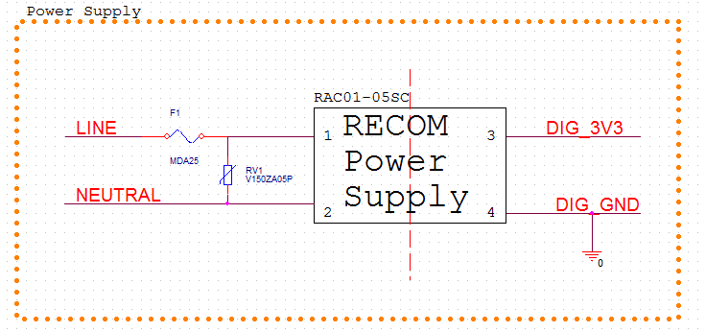

Figure 4 - Power Supply Schematic

### Generation 2 – Power Supply Implementation

Figure 5 shows an initial design for the second generation DC power supply.

Design Notes for Capacitively Coupled Power Supply:

* Based on the necessary DC voltages, and currents needed part values will change. Due to the many design factors still seen as unknowns.
* The basic operation of the circuit is as follows.
  + During positive half-cycles of the 120 VRMS sine wave, D1 is forward biased thus charging up the C3 capacitor. The rate of charging of the C3 capacitor is controlled by the C1, R1 impedance. C1 is used to limit the power dissipated, and R1 is used to handle in-rush currents when power is initially applied.
  + During negative half-cycles of the 120 VRMS sine wave, D2 is forward biased to maintain AC current through C1.
  + The R2 resistor was selected to bias the Q1 transistor. The D5 zener diode, is used to keep the base of the Q1 transistor at a given voltage. This allows the Q1 transistor to act as a voltage regulator, with an output voltage given by Vz(D5) – 0.7V or approximately 5 VDC.

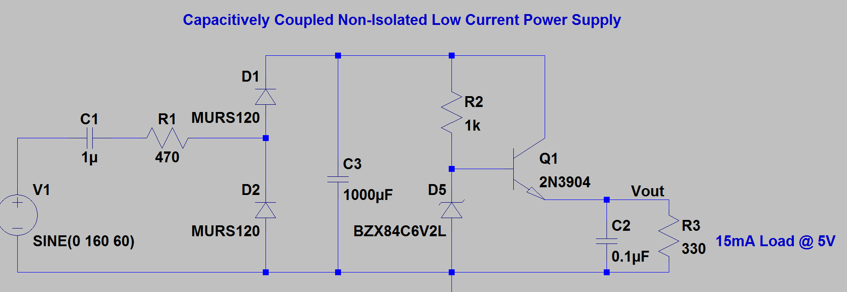

Figure 5 – Capacitively Coupled Power Supply

### Power Supply Design Risk Mitigation Summary

By splitting the power supply design into two generations, the more complex but manageable power supply risk is saved until more important risks such as power line communication, circuitry interfacing and controller programming are mitigated. Generation 1 provides a reliable and proven solution which will lead to a reduction of unknowns during the prototyping/debugging process. The RECOM power supply mitigates all risk as it is a proven design component which is part of a family providing many DC voltage output and power options. If time allows the generation two power supply design will be implemented due to the cost savings which it provides.

## Load Switch

The load switch must be capable of switching the power across the load, while preferably having its control circuit electrically isolated from the AC line.

A schematic showing the implementation of the load switch is shown in Figure 7.

Design Notes for load switch:

* MOC3063M refers to an optically coupled triac driver with zero crossing circuitry. The functional schematic for the MOC3063M, per the data sheet, is shown in Figure 6. The MOC3063 is an optical triac driver, thus allowing an isolated source to drive a triac. The M0C3063 also has zero crossing circuitry thus eliminating the need for timing the triac fire pulse with the ac line zero cross. To turn the triac ON, the LED between 1 and 2 must be illuminated (current flowing thru device). To turn the triac OFF, the LED between pins 1 and two must be non-illuminated (no current flow thru device).
* Due to the build in zero crossing circuit the MOC3063M traic driver cannot be used for implementing phase control switching of the triac. There are pin compatible opto triac drivers without internal zero crossing circuitry which can be used if it is later determined that the design should be capable of lamp dimming.

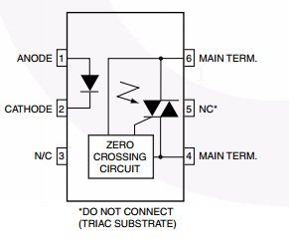

Figure 6 - MOC3063 Functional Diagram

* The operation of the load switch is as follows:
* OFF – When off functionality is required the processor will drive its output low. This will turn off the Q2 transistor thus providing no current flow thru the light emitting diode.
* ON – When on functionality is required the processor will drive its output high. This will cause a base current turning on the Q2 transistor and providing a current to flow illuminating the diode of the MOC3063 part.
* R5 is provided to limit the current when the load switch is on to (3.3V – Vled) / 510 ohms.
* R3 is chosen to limit the Q2 base current to (3.3V-0.7V)/10 kohms.
* R4 is chosen such that the transistor will be connected to ground when the processor output is open thus insuring the load switch will remain off when not driven by the processor, which is seen as good practice as this guarantees the device will not falsely turn on.
* An RC snubber (R1 and C1) is designed to limit the rate of change in voltage with respect to time thus preventing the triac from erroneously turning on.
* The triac Q1 is used to switch the AC power across the load. When the gate is ON the triac acts as a short circuit, whereas when the gate is OFF the triac acts as an open circuit once any existing load current drops below the holding current. The triac is bidirectional and therefore will conduct current for both the positive and negative cycles. The triac was selected to safely switch 20 amp continuous loads in 120 VRMS circuits. It will need to be mounted on a heat sink to run high current loads continuously.
* R2 is used to connect the gate of the triac to the main terminal when the gate is not being driven to zero thus preventing the triac from false latching on.

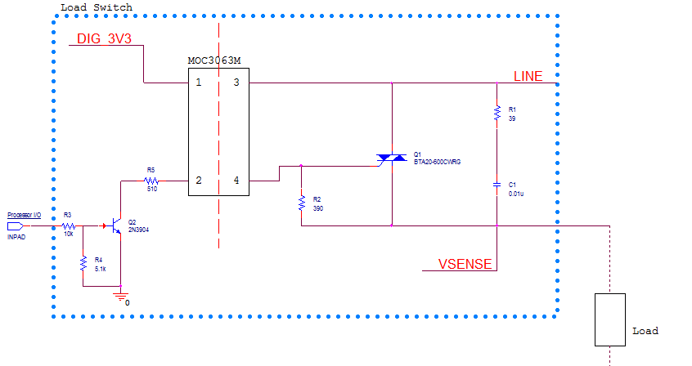

Figure 7 - Load Switch Schematic

### Load Switch Design Risk Mitigation Summary

The use of a triac with an MOC3063M optical driver mitigates the risk of load switching as it provides an inexpensive proven solution. The triac implementation unlike other alternatives, such as relays or transistor switching networks, meets all required design functionality and provides the opportunity to meet stretch goals such as modifying the phase angle of the load thus providing dimming functionality. The chosen solution also provides electrical isolation between the line electronics and the digital electronics which will be an important safety feature during the prototyping process.

## Power Sensing

Power sensing has been broken up into two sub-modules of current and voltage sensing. Thru the acquisition of the voltage and current characteristics important power parameters can be tracked. Current sensing circuitry which generates an analog voltage proportional to the sensed current, and voltage sensing circuitry which generates a voltage proportional to the sensed voltage will be fed into ADC converters of the chosen controller which will then use this information to determine the current and voltage waveforms in real time.

### Current Sensing

The designed current sensing circuit schematic is shown in Figure 10.

Design Notes for Current Sensing:

* The ACS722 refers to a Hall Effect current IC manufactured by Allegro. A block diagram showing the chip functionality, from the data sheet, is shown in Figure 8.

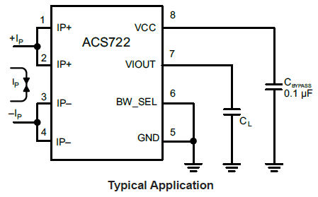

Figure 8 – Hall Current Sensor IC Typical Usage per Datasheet

* The ACS722 will measure a bidirectional current which is run through pins 1, 2 and 3, 4. An output voltage will be generated on pin 7 which be proportional linearly to the sensed current with an offset of Vcc / 2. Figure 9 shows the expected voltage outputs for various current levels.

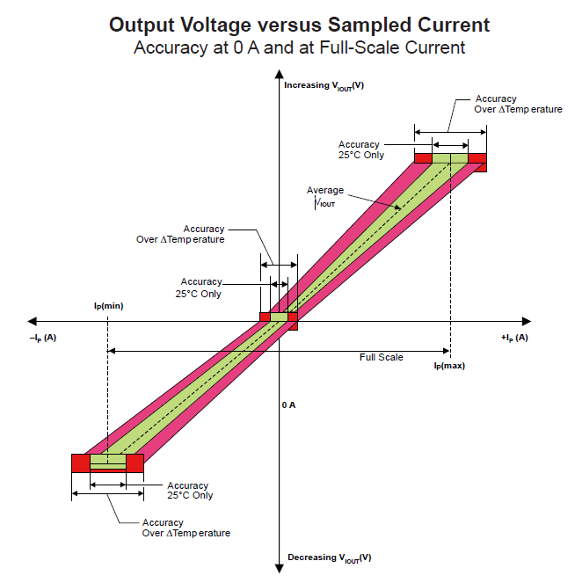

Figure 9 - Input Current vs Output Voltage Characteristics of Current Sense Chip

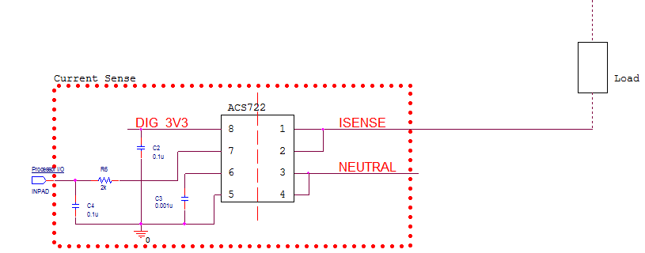

Figure 10 - Current Sense Circuit Schematic

* C2 is a decoupling capacitor recommended by the data sheet application note.
* C3 is a filter capacitor recommended by the data sheet application note.
* C4 is an optional filter capacitor which may be needed depending on the signal integrity of the output voltage.
* R6 is a current limiting resistor, to protect the processor from sinking too much current.

#### Current Sensing Design Risk Mitigation Summary

The use of a Hall Effect current sensor mitigates the risk of current sensing as it provides an inexpensive proven solution. The Hall Effect solution provides electrical isolation between digital electronics and the AC line and also has no loading effect on the load. For its value the Allegro IC gives the most performance. Also little external circuitry is needed.

### Voltage sensing

The designed voltage sense circuit schematic is shown in Figure 12.

Design notes for Voltage sense:

* The ACPL-C87A refers to an integrated circuit which provides an optically isolated amplifier designed specifically for voltage sensing. It has a 2V input range and a high input impedance thus minimizing its loading effects. A differential output voltage that is proportional to the input voltage is created on the output side of the optical isolation barrier. The part uses sigma-delta modulation technology to transmit the signal information digitally across the isolation boundary. The functional block diagram for this part can be seen in Figure 11.

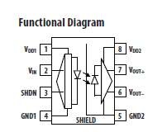

Figure 11 –ACPL-C87A Functional Diagram

* The ACPL-C87A provides an isolated amplifier allowing the controller to sample the line voltage. The ACPL-C87A requires two isolated supply voltages: one for the digital side, and one for the line side. The digital voltage DIG_3V3 can be provided by the main power supply. The line voltage can NOT be supplied by the digital generated voltage DIG_3V3 as this would break the isolation barrier defeating the purpose of the chip. Therefore to provide a 5V reference to Neutral, a simple capacitively coupled power supply is generated which is capable of sourcing the 15mA required by the isolated amplifier input side circuitry.
* The capacitively coupled power supply is shown below the green box of the Voltage Sense block. It takes the line (120 VRMS) with respect to Neutral and produces a 5V reference capable of providing 15 mA. The functionality of this capacitively coupled supply is the same as the capacitively coupled supply discussed in the generation 2 power supply design section.
* The voltage sense circuit senses the line voltage, feeds a part of this voltage into the isolation amplifier, which then allows the processor to determine the sensed voltage.
* R7, R8, R9 and R10 function as a voltage divider such that the 120 VRMS line voltage is scaled down to 2V to be fed into the isolation amplifier. The maximum line voltage was assumed to be 160 VRMS, so this value was to correspond to 2V as seen by the isolation amplifier input. The chosen resistor values result in the following input voltage at 160 VRMS.
$$V_{in}=\frac{3.9k}{303.9k}*160=2.05V$$

* The series connection of R7, R8, and R9 is the part of the voltage divider responsible for dropping most of the line voltage. Therefore a large value of 300k ohms was chosen to minimize power dissipation. (V2/R). This resistor was also split up into three resistors, which is standard practice in this application as it allows for the power dissipation to be divided among three different resistors instead of having all of the power dissipated across one resistor. In this configuration, the maximum possible power dissipation of each R7, R8 and R9 is 27.738 mW.

$P=\frac{V^{2}}{R}=\frac{{\left(\frac{158 V}{3}\right)}^{2}}{100 kohms}=27.7 mW$

* 158 V is the voltage to be dropped across the total series combination of R7, R8 and R9. Since all resistors are of equal value the voltage will be evenly split across each resistor.
* 100kohms is the chosen value of the resistors.
* C5 is a filter capacitor for the amplifier input voltage.
* C6 and C7 are decoupling capacitors as specified by the datasheet.
* The amplifier with resistors R12, R11, R13, and R16 is a balanced differential amplifier capable of performing signal conditioning and gain adjustment which may or may not be needed.

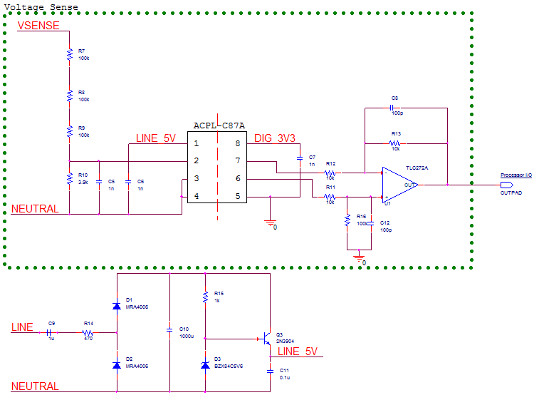

Figure 12 - Voltage Sense Schematic

#### Voltage Sense Design Risk Mitigation Summary

The use of an isolated amplifier mitigates the risk of voltage sensing as it provides an inexpensive proven solution. The isolation amplifier solution provides electrical isolation between the digital control electronics and the AC line and also has little effect on the load.

## Surge Protection

The risk of surge protection was easily mitigated as almost all electronics currently manufactured have some form of surge protection. Therefore there are many different implementations to handle surge protection. The selected solution consisted of a slow blow fuse and an MOV as shown in Figure 4. Both the fuse and the MOV will have no effect on the circuit during normal operation. In the event of a surge voltage transient, the MOV will dissipate any excess energy thus keeping the line voltage from exceeding 160V. In the event of the MOV failing as a short circuit the fuse will burn out thus breaking the path of current flow and protecting all circuit components.

### Surge Protection Design Risk Mitigation Summary

Based on the results of this investigation, this risk has been deemed a non-issue and is no longer a major issue due to the many implementations in products on the market.

## Controller

The controller to be used is the MSP430 and is responsible for the tasks shown in Figure 13. Rectangular blocks within the controller correspond to software blocks which will be developed, and oval block correspond to external hardware circuitry that the controller will interface with. The tasks which are shown in Figure 13 are described as follows:

* Programming Interface – Provide an interface which can be used to program the MSP430 such that iterative development can take place
* LED Driver – Status LEDs providing user feedback are desired. The LED driver is responsible for determining state of LEDs and turning them OFF or ON depending on desired functionality.
* Current Monitoring Driver – The current monitoring driver is responsible for handling the samples from the current sense hardware. The current sense hardware shall also decipher the results of the current sense hardware and produce a result usable for power calculations.
* PLC Controller- Provide an interface to communicate off chip via the power line communication hardware. Tasks will include transmitting and receiving data between remote and main units.
* Power Calculations – Provide power calculations based on current and voltage measurements. While exact calculations to perform are still unknown at this point likely characteristics include: power factor, instantaneous real and apparent power dissipated, average power dissipated, kW/hours etc.
* Current Voltage Phase Calculations: Current and voltage phase calculations will be necessary to determine the power factor.
* Load Switch Driver – Provides control of the load switch hardware, by commanding the load to the ON or OFF condition. This block will also be responsible for shutting the load switch off in the event of an over current/voltage fault.
* Voltage Monitoring Driver- The voltage monitoring driver is responsible for handling the samples from the voltage sense hardware. The voltage sense hardware shall also decipher the results of the voltage sense hardware and produce a result usable for power calculations.



Figure 13 - Controller Diagram

### Controller Design Risk Mitigation Summary

The MSP430 mitigates the design risk as extensive application notes and source code are provided which can be used as the basis control firmware for this project. The MSP430, which is made by Texas Instruments has excellent development tools which will be important during project development.

### Intellectual Property

With the smart grid industry on the rise there are many provided resources such as example code, and application notes. For example companies such as Texas Instruments, in an effort to encourage design engineers to choose their products, make available at no cost application notes, and sample code which can be used. Therefore the programming effort for this design will most likely heavily leverage available example code. Also there are many open source projects that have been developed in the past which can be looked to for reference. In addition to example code, energy metering algorithms are also provided by Texas Instruments. These algorithms along with the public domain code will serve as a basis for the embedded development effort. Similar public domain code may also be used for power line communication pending the results of a separate ongoing independent investigation.

# Parts List

The parts list for the major components of the risk reduction design investigation is provided in Table 13. Part selection was limited to components that were in stock at DigiKey a well-known national electronics distributor. Table 13 provides hyperlinks to component datasheets by selecting the part number. The final column in the table indicates what functional block of the design the particular component is used in. The cost per unit listed is the low quantity Digikey cost. It is also anticipated that a printed circuit board will be designed and fabricated using an online prototype shop such as Sunstone. The cost for fabricating a couple of blank pcbs is estimated to be $250. In addition, Texas Instruments offers evaluation boards of their MSP430 microcontrollers for energy meter applications. An EVM430-F6779 is available from DigiKey for $310. Although expensive, this or a similar unit will be investigated as a potential platform for power management firmware development.

Table 13 – Risk Reduction Design Major Component Parts List

|  |  |  |  |  |  |  |  |  |  |  |  |  |  |
| --- | --- | --- | --- | --- | --- | --- | --- | --- | --- | --- | --- | --- | --- |
| Part Number | Description | Vendor | | Cost  per Unit | | | Qty | | Ext Cost | | Lead Time | | Functional Block |
| [RAC01-05SC](http://www.recom-power.com/pdf/Powerline-AC-DC/RAC01_02-SC.pdf) | AC/DC switching power supply | Recom | | $ 12.34 | | | 1 | | $ 12.34 | | stock | | Power Supply |
| [V150ZA05P](http://www.littelfuse.com/~/media/electronics/datasheets/varistors/littelfuse_varistor_za_datasheet.pdf.pdf) | Varistor | Littelfuse | | $ 0.56 | | | 1 | | $ 0.56 | | stock | | Power Supply |
| [MOC3063M](http://www.fairchildsemi.com/datasheets/MO/MOC3061M.pdf) | Optoisolator | Fairchild Semi | | $ 0.95 | | | 1 | | $ 0.95 | | stock | | Load Switch |
| [MMBT3904](http://www.fairchildsemi.com/datasheets/MM/MMBT3904.pdf) | NPN Transistor | Fairchild Semi | | $ 0.15 | | | 1 | | $ 0.15 | | stock | | Load Switch |
| [BTA20-600CWRG](http://www.st.com/web/en/resource/technical/document/datasheet/CD00004893.pdf) | Triac | STMicroelectronics | | $ 1.97 | | | 1 | | $ 1.97 | | stock | | Load Switch |
| [ACS722](http://www.allegromicro.com/~/media/Files/Datasheets/ACS722-Datasheet.ashx) | Hall Effect Current IC | Allegro | | $ 5.27 | | | 1 | | $ 5.27 | | stock | | Current Sense |
| [ACPL-C87A](http://www.avagotech.com/docs/AV02-3563EN) | Isolated Voltage Sense | Avago | | $ 6.42 | | | 1 | | $ 6.42 | | stock | | Voltage Sense |
| [TLC272A](http://www.ti.com/lit/ds/symlink/tlc272a.pdf) | dual op-amp | TI | | $ 1.35 | | | 1 | | $ 1.35 | | stock | | Voltage Sense |
| [MMBT3904](http://www.fairchildsemi.com/datasheets/MM/MMBT3904.pdf) | NPN Transistor | Fairchild Semi | | $ 0.15 | | | 1 | | $ 0.15 | | stock | | Voltage Sense |
| [MSP430F672](http://www.ti.com/lit/ds/symlink/msp430f6720.pdf) | Embedded Microcontroller | TI | | $ 7.31 | | | 1 | | $ 7.31 | | stock | | Controller |
| [BZX84C5V6](http://www.fairchildsemi.com/datasheets/BZ/BZX84C10.pdf) | 5.6 Zener Diode | Fairchild Semi | | $ 0.19 | | | 1 | | $ 0.19 | | stock | | Voltage Sense |
| [MRA4006](http://www.onsemi.com/pub_link/Collateral/MRA4003T3-D.PDF) | 1A, 800V diode | On semi | | $ 0.31 | | | 2 | | $ 0.62 | | stock | | Voltage Sense |
|  |  | |  | |  |  | |  | |  | |  | |
|  | Module | | | | | | | Cost | | | |  | |
|  | Power Supply Cost | | | | | | | $ 12.90 | | | |  | |
|  | Load Switch Cost | | | | | | | $ 3.07 | | | |  | |
|  | Current Sense Cost | | | | | | | $ 5.27 | | | |  | |
|  | Voltage Sense Cost | | | | | | | $ 8.73 | | | |  | |
|  | Controller | | | | | | | $ 7.31 | | | |  | |
|  | Total Material Cost | | | | | | | $ 37.28 | | | |  | |

# Testing Strategy

To begin risk testing as soon as possible, a phased approach will be taken. The test shall be broken up into the following four phases:

Phase 1 – Breadboard Testing of Functional Blocks

Phase 2 – Initial firmware Development with Processor Eval Board

Phase 3 – Interface processor evaluation board to functional blocks

Phase 4 – Prototype Evaluation – A dedicated custom pcb will be designed with the final design.

The testing to be carried out at each phase is described below.

## Phase 1

### Power Supply

The power supply shall be tested as follows.

* + - 1. Apply 120 VAC to terminals 1,2 of Recom power supply and at no load measure the output voltage. Verify that a DC voltage of 3.3V is produced at pin 3 with respect to pin 4.
      2. Apply resistors across pins 3 and 4 ranging from 1k to 4.8k. Verify that at load 3.3V is seen across the resistor.

### Surge Protection

Surge protection will be verified purely through analysis as the test equipment for surge signal generation is expensive and unavailable to the design team. The surge protection devices used are UL recognized components and therefore the manufacturer guarantees they will meet the minimum requirements specified in the datasheet.

### Voltage Sense

The voltage sensing circuitry shall be tested by applying a variety of known voltages to the voltage sense input and verifying the output is as expected.

1. Measure and plot the output voltage vs the input voltage over 0 to 160 volts and 0 to -160 volts in 5V steps.
2. Measure the frequency response by injecting 2V peak to peak input signal with a sine wave generator from 10 Hz to 10 kHz.
3. Measure the supply current draw on the input side of the circuit.
4. Measure the voltage output of the capicatively coupled power supply at the required supply current for the voltage isolation amp.

### Current Sense

The current sensing circuitry will be tested by running a simulated load current through the measured current trace and verifying that the measured current is the same as the applied current.

1. Measure and plot output current cs input current over 0 to 20 A and 0 to -20 A in 1 A steps.
2. Measure frequency response by injecting a step current command from 0 to 5 A using a power transistor switch.

## Load Switch

The load switching circuitry will be tested as follows.

1. For loads ranging between 5 to 20A verify that when in the OFF condition there is no current flow thru the load. When in the ON position the current thru the load is limited only by the load impedance and not by the switching circuitry.
2. Check that switching occurs at AC line zero crossing circuit is accurately and turns off at next zero crossing in absence of opto ON signal.
3. Determine heat-sinking required for triac at full load current of (20 A)
4. Make temperature rise measurements of triac with heatsink when operating at 20 A.

## Phase 2

Controller algorithms will be tested prior to hardware implementation using simulation design tools provided by Texas Instruments to verify proper functionality.

1. Verify the ability to load and execute code by demonstrating blinking an LED on evaluation board.
2. Verify ability to read ADC input values by interfacing signal generator test samples.
3. Verify ability to use timer module to count the period of a signal generator test signal.

## Phase 3

1. Interface the breadboard voltage sensing circuit to the evaluation board.
   1. Demonstrate the ability to read voltages input to the ADC statically
   2. Demonstrate the ability to read voltages input to the ADC dynamically at frequencies up to 10kHz.
   3. Demonstrate ability to process voltage information i.e. compute average voltage.
   4. Demonstrate ability to calculate line frequency from voltage waveform.
2. Interface the breadboard current sensing circuitry to the evaluation board.
   1. Demonstrate the ability to read current input to the ADC statically.
   2. Demonstrate the ability to read current input to the ADC dynamically at frequencies up to 10kHz.
   3. Demonstrate the ability to process current information i.e. compute average current.
3. Demonstrate ability to simultaneously sample current and voltage.
   1. Demonstrate ability to calculate phase angle between voltages and current.
   2. Demonstrate ability to calculate power from sensed voltage and currents
4. Interface the load switch breadboard to the evaluation board.
   1. Demonstrate the ability to switch a load On and OFF, using a evaluation board pushbutton.
5. Interface processor evaluation board to power line communication breadboard. (NOTE: Power line communication test plan covered by another team member.)
6. Demonstrate full functionality of breadboard and evaluation board.

## Phase 4

Repeat qualification plan for breadboard phase with the prototype PCB design. Additional prototype tests shall be added as required.

The PCB shall be laid out with many test points thus allowing for easy access to all important signals during the debugging process.

## Testing Schedule

The initial testing schedule is provide in Table 14. Adjustments to the schedule may be made depending upon fit with the other team members risk analysis.

Table 14 – Preliminary Testing Schedule

|  |  |
| --- | --- |
| Phase 1 – Breadboard Testing | April 2015 |
| Phase 2 – Controller Eval / Firmware Testing | May 2015 |
| Phase 3 – Controller Eval Integration with Functions | September - October 2015 |
| Phase 4 – Prototype Testing | October – November 2015 |

# Uncertainties

## Power Supply

Currently the PLC interface is being alternatively investigated. Therefore the load on the power supply is not completely known at this time. The implementation of a generation one and two power supply design mitigates this risk, as generation one provides a solution capable of producing in excess of 3W of power. Once the design is more finalized, the loading of the power supply will be more well-known thus allowing for the completion of generation two of the power supply design.

## Surge Protection

There are no uncertainties regarding aspect of the project.

## Switching Control

There are no uncertainties regarding aspect of the project.

## Current Sensing

The remaining uncertainties for the current sensing is the rate at which to sense the current. This is not deemed high-risk as the processor is able to sample at speeds much faster than 60 Hz.

## Voltage Sensing

The remaining uncertainties for the voltage sensing is the rate at which to sense the voltage. This is not deemed high-risk as the processor is able to sample at speeds much faster than 60 Hz.

## Controller

The remaining uncertainties for the controller are the requirements of the power line communication interface which will be required. Uncertainties include: number of I/O needed, communication protocols with PLC chip, data transmission speeds, power calculations needed, and the sampling rate. These factors will be strongly impacted by the web UI design and which parameters are chosen to be tracked.

# Appendix

There is extensive documentation on the web in regard to smart grid and energy which is directly applicable to the Energy Management System project. Links to relevant manufacturer sites and app notes are provided below.

[Texas Instruments Smart Grid & Energy Products Overview](http://www.ti.com/lsds/ti/apps/smartgrid/plcmodem/overview.page?DCMP=plc&HQS=plc)

[PLC Motherboard with AC Mains Line Coupling Reference Board](http://www.ti.com/tool/TIDA-00192)

[Three Outlet Smart Power Strip Reference Design](http://www.ti.com/tool/tidm-3OUTSMTSTRP)

[Low Cost Two Phase Electric Meter](http://www.ti.com/tool/tidm-twophasemeter-i2040)

[Single Phase Electric Meter with Isolated Energy Measurement](http://www.ti.com/tool/TIDM-METROLOGY-HOST)

[MSP430 Energy Library](http://www.ti.com/tool/msp430-energy-library)

[TI Electric Metering Overview (Including Reference Designs)](http://www.ti.com/lsds/ti/apps/smartgrid/metering/overview.page)

[EVM430-F6779 Evaluation Module](http://www.digikey.com/product-detail/en/EVM430-F6779/296-37565-ND/4814039http:/www.digikey.com/product-detail/en/EVM430-F6779/296-37565-ND/4814039)

[AN954 Transformerless Power Supplies: Resistive and Capacitive](http://www.google.com/url?sa=t&rct=j&q=&esrc=s&source=web&cd=1&cad=rja&uact=8&ved=0CB4QFjAA&url=http%3A%2F%2Fww1.microchip.com%2Fdownloads%2Fen%2FAppNotes%2F00954A.pdf&ei=m2EhVcDsO5etoQTQ64HwDA&usg=AFQjCNE2WqAo344_7Whjy8_ji0Z5POHr_Q&bvm=bv.89947451,d.aWw)

[RECOM Power Supply Application Notes 2015](http://www.recom-power.com/fileadmin/Media/Folder-Flyer/App_Notes_27112014.pdf)

[Smart Street Lighting Remote Control Protocol over Power Line Communication](http://www.st.com/st-web-ui/static/active/en/resource/sales_and_marketing/promotional_material/magazine/TP1924%20ST%20Smart%20Street%20Lighting%20-%20Final.pdf)

[Current Sensing In Metering Applications Using A Pulse Current Sensor](http://www.google.com/url?sa=t&rct=j&q=&esrc=s&source=web&cd=1&cad=rja&uact=8&ved=0CB4QFjAA&url=http%3A%2F%2Fwww.st.com%2Fst-web-ui%2Fstatic%2Factive%2Fen%2Fresource%2Ftechnical%2Fdocument%2Fapplication_note%2FCD00289924.pdf&ei=Q2MhVcvULIPuoAS-1IGoCw&usg=AFQjCNHHq6Ua8waZzbd-OZCn0G4r22B4pg&bvm=bv.89947451,d.aWw)

[Isolation Amplifier for Voltage Sensing in Electric and Hybrid Vehicles](http://www.avagotech.com/docs/AV02-1790EN)

[STPM01 Programmable Single Phase Energy Metering IC with Tamper Detection](http://www.st.com/web/en/resource/technical/document/datasheet/CD00044094.pdf)

[OnSemi Transient Overvoltage Protection Guide](http://www.onsemi.com/pub_link/Collateral/TND335-D.PDF)

[STPM Smart Metering ICs Overview](http://www.st.com/st-web-ui/static/active/cn/resource/sales_and_marketing/presentation/product_presentation/STPM3_pres.pdf)

[STPM01 Energy Metering IC External Circuits Application Note](http://www.st.com/st-web-ui/static/active/en/resource/technical/document/application_note/CD00091951.pdf)

[A Low Cost Single Phase Electricity Meter Using the MSP430C11x](http://www.ti.com/lit/an/slaa075/slaa075.pdf)

[Energy Meter Code Library for 1-Phase to 3-Phase Using MPS430 Family](http://www.ti.com/lit/an/slaa538/slaa538.pdf)

[A Low Cost Home Automation System Base On Power Line Communication Links](http://www.iaarc.org/publications/fulltext/isarc2005-41mainardi.pdf)

[Fundamentals of AC Power Measurements](http://www.tek.com/dl/55W_28941_0_MR_Letter.pdf)